**Thank you!**

Your congregation

generously gave

$

to Mission Support

in 2024

**Thank you!**

Your congregation

generously gave

$

to Mission Support

in 2024



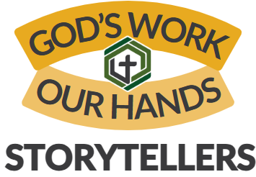

In 2024, congregations of the Northeastern Pennsylvania Synod contributed a total of $**1,592,831.81** to undesignated Mission Support. Of this total amount, $844,200. stayed in the Synod. What are we doing together, right here in the NEPA Synod with your gifts?

* We support new pastors and deacons. Join us in thanking God for the 14 candidates discerning calls to public ministry and the 10 rostered ministers welcomed into our synod to serve ministry sites in 2024-2025.
* Together, we work on Growing Young. Find more about the 6 Core Commitments for living as a Jesus-centered community on the website.
* Our newly launched Licensed Lay Ministry formation process seeks to support the mission happening in local congregations. Congregations in the NEPA Synod brought forward 34 LLM entrants.
* Because of your mission support, we get to try bold experiments like 6261.
* Gaining Strength cohorts give deacons and pastors training in fostering collaboration and practice in innovative ministry skills.

Thank you for your 2024 Mission Support Commitment.

Find out more about what your generous offerings to Mission Support do at the Synod’s website: [godslove.org/missionsupport](https://nepasynod.org/stories-of-faith-in-action/)

**Thank you!**

Our congregation

generously gave to

Mission Support in 2019

In 2024, congregations of the Northeastern Pennsylvania Synod contributed a total of $1,592,831.81 to undesignated Mission Support. Of this total amount, $844,200. stayed in the Synod. What are we doing together, right here in the NEPA Synod with your gifts?

* We support new pastors and deacons. Join us in thanking God for the 14 candidates discerning calls to public ministry and the 10 rostered ministers welcomed into our synod to serve ministry sites in 2024-2025.
* Together, we work on Growing Young. Find more about the 6 Core Commitments for living as a Jesus-centered community on the website.
* Our newly launched Licensed Lay Ministry formation process seeks to support the mission happening in local congregations.
* Congregations in the NEPA Synod brought forward 34 LLM entrants.
* Because of your mission support, we get to try bold experiments

like 6261.

* Gaining Strength cohorts give deacons and pastors training in fostering collaboration and practice in innovative ministry skills.

Thank you for your 2024 Mission Support Commitment.

Find out more about what your generous offerings to Mission Support do at the Synod’s website: [godslove.org/missionsupport](https://nepasynod.org/stories-of-faith-in-action/)