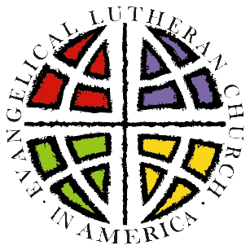
What’s next?
The Call Process
of the
Northeastern Pennsylvania Synod

You have a partner in the Bishop’s Office guiding you through a call process in which the Holy Spirit works.

Recognizing that adjustments will be made to your congregation's process, here is what you can expect in this time of transition:
- The bishop, with your council's approval, may appoint an transition pastor to serve with you. This pastor might be a designated pastor or an interim pastor.
2. Your council will establish a contract with the transition pastor and will negotiate responsibilities and compensation.
3. A variety of gatherings will occur during the transition. Representatives of the bishop will address questions, listen to ideas about ministry, describe the process in more detail and gather information
4. A call committee will be established according to the guidelines of your constitution.
5. The associate of the bishop assigned to your mission district will provide orientation to your call committee.
6. The council and call committee will write a Ministry Site Profile (a description of your congregation and the qualities you are looking for in a pastor).
7. The call committee will receive the Rostered Minister Profile of potential candidate(s).
8. The call committee will enter an interview process with the candidate(s).
9. The call committee will keep you informed of the progress of its work. The specifics of the potential candidate(s) are all confidential at this point.
10. After the call committee discerns a primary candidate, the committee and the candidate will meet with the council.
11. The council through its officers and the call committee chairperson will prepare a letter of compensation and benefits for the candidate.
12. The council will vote to recommend the candidate (with at least a 2/3 majority) to the congregation.
13. Members of the congregation will be given the opportunity to meet the candidate.
14. There will be a special congregational meeting to formally vote on the candidate.
15. If a congregation votes "yes" (with a minimum 2/3 majority), a letter of call is signed and forwarded to the bishop and sent to the pastor.
16. The candidate has 30 days to consider the call. If the candidate accepts the call, an installation date is set. If the candidate declines the call, the call committee goes back to work with the associate and synod bishop.

Through the whole process, your prayers are essential.
Pray that the Holy Spirit guide you, your call committee, your council and your synod in discerning whom God is calling to serve as your next pastor.
Northeastern Pennsylvania Synod
God's Work. Our Hands.
2354 Grove Road
Allentown, PA 18109-3044
info@nepsynod.org; 610-266-5101

